选择性必修二U2 Sports culture
Reading
The Olympic Games
一、教材分析
本文本的主题语境是“人与社会”,话题是“体育文化、体育精神”，涉及的语篇类型是网站文章。本文处于Reading板块，介绍了奥运会的发展历史、奥运名将的励志故事以及中国在奥运方面取得的成就，帮助学生领会奥林匹克精神，培养民族自豪感，并学会将体育融入生活。

- 学情分析
高二学生已具备一定的英语阅读能力和词汇基础，对“奥运会”这一主题有了基本了解和文化兴趣，这为本课学习提供了良好的起点。本课重点在于激发学生已有知识的同时，引导他们深入理解文本内涵，并系统梳理和巩固相关语言知识，最终提升其批判性思维和文化鉴赏能力。

三、教学目标
By the end of this section, students will be able to
1. summarize different paragraphs with subheadings;
2. achieve a deep understanding of the Olympic Games and the Olympic spirit;
3. learn from Olympic athletes and apply their spirit to daily study and growth.

四、教学重难点
1.Summarize different paragraphs with subheadings;
2.Understand the deep meaning of the Olympic Games and the Olympic spirit.

- 教学方法
PWP Pattern, Communicative Principle,Multi-model Teaching Approach

- 教学工具
A multi-media player, some common teaching tools

- 教学步骤
Step 1 Lead in
Enjoy a video and answer the following questions.
- What does the short video show to us?
- What words come to your mind when you think of the Olympic Games?
【设计意图：通过看视频激活学生已有的体育知识，通过询问学生一些问题激发学生对于奥运会的兴趣,快速切入主题。】
Step 2: Reading
- Pre-reading
What do you know about the Olympic Games?
【设计意图：检查预习情况，进一步调动学生的知识储备，为阅读文章做好内容上的铺垫。】

- While-reading
Skimming for main idea and structure.
Have students find the main idea of each paragraph and summarize different paragraphs with subheadings.
【设计意图：帮助学生对文章结构和文章内容有整体的理解。】

Detailed reading
Para.1 Introduction
Q: What is the spirit of the Olympic Games?

Para.2-3 Histrory of the Olympic Games
1)Have students read Paras. 2-3 and fill in the table with key words.
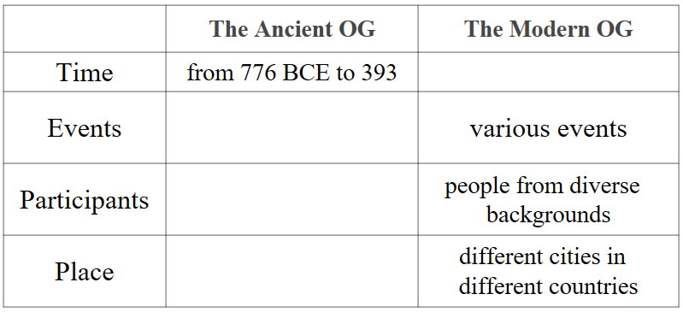
- Compare the differences between the ancient Olympics and the modern Olympics.
- Why could modern Olympics become more international and fair?
To help people of different racial origins and from different cultures live side by side in peace.
-------Pierre de Coubertin
Para4-5: Well-known athletes
- Find the detailed information about the two Olympians and fill in the blanks.
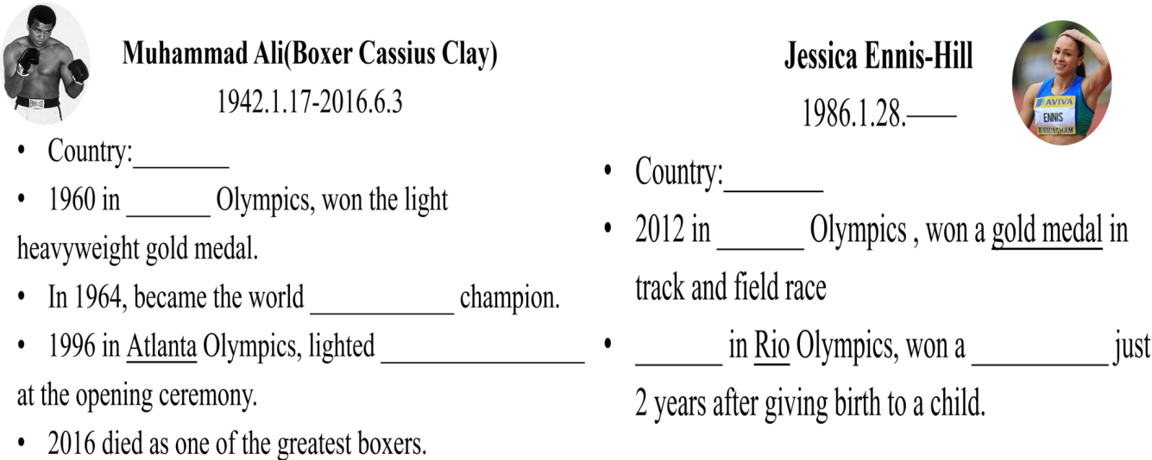
- What’s the secret to their success?
3）Sharing-time Who is the Olympic hero in your mind?
My Olympic hero is _________. She/He is a(n) _________. I am impressed by her/his spirit of _________, which always inspires me to_________________.

Para6: China and the Olympics
1)Figure out China’s achievements and fill in the table.
China’s achievements
1984 Los Angeles Olympics
2004 Athens Olympics
2008 Beijing Olympics
2016 Rio Olympics
Beijing successfully hosted the 2022 Winter Olympics.
2）What trend does China sport show?
3）What are the key factors behind China’s success?

Summary:
The strength of a nation lies in the strength of its youth.
The strength of a nation lies in the strength of its sports.
The hope is on your shoulders.
——Xi Jinping
【设计意图：帮助学生获得对文章的详细信息，加深学生对文章的理解。引导学生领会奥运精神，激励学生形成积极向上的价值观和生活态度，同时增强学生的民族自豪感和爱国情怀，坚定文化自信。】

Step 3Post-reading(Discussion)
Apart from joy and excitement , what other things does the Olympic Games teach us?
【设计意图：强调奥运会对人生的教育意义。】

Step 4 Homework (Write a speech)
2024年巴黎奥运会上中国体育健儿成绩傲人,青年学子备受鼓舞。为此,你校将举行主题为“学奥运,圆梦想”的英语演讲比赛,请你写一篇演讲稿参赛。
内容包括:(1)你对奥运精神的理解;
(2)你实现梦想的决心。
注意：词数80左右。
可适当增加细节,以使行文连贯。

